
Job Finding Application

NEOH KAI WEI
SCSJ2401128

Ts. Umi Kalsum Binti Muhamad

REPORT SUBMITTED TO FULFIL PARTIAL REQUIREMENTS FOR THE
CERTIFICATE INFORMATION TECHNOLOGY(CIT)
SEGI UNIVERSITY & COLLEGE SUBANG JAYA

March 2026

ABSTRACT
Malaysian job platforms such as JobStreet and LinkedIn often frustrate users, especially university students and part-time job seekers, due to lengthy registration processes that take 7–10 minutes, severe information overload, confusing navigation, poor search and filter functions, and the complete lack of direct employer contact details. These issues lead to high abandonment rates and prevent users from quickly finding suitable local or casual employment opportunities.
This project successfully developed a minimalist “Job Finding Application” prototype that eliminates unnecessary complexities by allowing users to browse nearby job listings without any registration or verification. The system provides instant access to employer phone numbers and addresses with a single click. Following the Waterfall methodology, a high-fidelity interactive prototype was designed and developed in Figma. Usability testing conducted with SEGi University students using the “10-second rule” confirmed that users could locate contact information within 10 seconds, significantly reducing cognitive load and frustration. The prototype offers a simple, fast, and truly user-friendly solution tailored for Malaysian job seekers.

ABSTRAK
Platform pencarian pekerjaan di Malaysia seperti JobStreet dan LinkedIn sering mengecewakan pengguna, terutamanya pelajar universiti dan pencari kerja sambilan, disebabkan proses pendaftaran yang panjang (7–10 minit), beban maklumat yang berlebihan, navigasi yang mengelirukan, fungsi carian dan penapis yang lemah, serta ketiadaan maklumat hubungan langsung dengan majikan. Masalah ini menyebabkan kadar pengabaian yang tinggi dan menghalang pengguna daripada mencari peluang pekerjaan tempatan atau santai dengan cepat.
Kajian ini telah berjaya membangunkan prototaip aplikasi “Job Finding Application” yang sangat ringkas, yang menghapuskan kerumitan yang tidak perlu dengan membolehkan pengguna melayari senarai pekerjaan berdekatan tanpa pendaftaran atau pengesahan. Sistem ini menyediakan akses segera kepada nombor telefon dan alamat majikan dengan satu klik sahaja. Menggunakan model Waterfall, prototaip interaktif berkualiti tinggi telah direka dan dibangunkan di Figma. Ujian kebolehgunaan yang dijalankan dengan pelajar Universiti SEGi menggunakan peraturan “10 saat” menunjukkan bahawa pengguna boleh mendapatkan maklumat hubungan dalam masa 10 saat, dengan ketara mengurangkan beban kognitif dan kekecewaan. Prototaip ini menawarkan penyelesaian yang mudah, pantas dan mesra pengguna untuk Malaysia job seekers.

PREFACE
This Final Year Project report is submitted in partial fulfilment of the requirements for the Certificate of Information Technology (Integrated Systems) at SEGi University & College, Subang Jaya, Malaysia.
The project titled “Job Finding Application” was developed to address the real frustrations faced by university students and part-time job seekers in Malaysia when using existing platforms such as JobStreet and LinkedIn. By creating a minimalist mobile prototype, this study aims to provide a simple, fast, and user-friendly solution that eliminates lengthy registration, information overload, and lack of direct employer contact.
I would like to express my deepest gratitude to my supervisor, Ts. Umi Kalsum Binti Muhamad, for her continuous guidance, valuable feedback, and encouragement throughout the project. Special thanks to my family and friends for their unwavering support. This project is the result of hard work and dedication, and any shortcomings are entirely my own responsibility.

Acknowledgment
I would like to express my deepest gratitude to my supervisor, Ts. Umi Kalsum Binti Muhamad, for her invaluable guidance, patience, constructive feedback, and constant encouragement throughout the development of this Final Year Project. Her insightful suggestions have greatly shaped the direction and quality of this “Job Finding Application” prototype.
Finally, I would like to thank SEGi University & College for providing the resources and learning environment that made this project possible. Any shortcomings in this report are entirely my own responsibility.

Table of Contents
Chapter 1 10
INTRODUCTION 10
Title: Job Finding Application 10
1.1 Introduction 10
1.2 The Aim of Project 10
1.3 Problem Statement 11
1.4 Objective 11
1.5 Conclusion 12
CHAPTER 2 13
LITERATURE REVIEW 13
2.1 Introduction 13
2.2 The Current State of Mobile Job Seeking in Malaysia 13
2.3 The Problem of System Complexity and Information Overload 14
2.4 Barriers for Small Businesses and General Workers 14
2.5 Comparison of Related Articles 15
2.6 Comparison of existing system 19
2.7 Conclusion 20
CHAPTER 3 21
METHODOLOGY 21
3.1 Introduction 21
3.2 Waterfall Model 22
3.3 Main Requirements 25
3.4 Hardware and Software Requirements 25
3.5 Testing Strategies 25
3.6 Conclusion 26
CHAPTER 4 27
SYSTEM DESIGN 27
4.1 Introduction 27
4.2 Use Case Diagram 28
4.3 System Flow Chart 29
4.4 ERD Diagram 30
4.5 Conclusion 30
CHAPTER 5 31
PROTOTYPE 31
5.1 Introduction 31
5.2 Prototype 32
5.3 Conclusion 34
CHAPTER 6 35
TESTING AND EVALUATION 35
6.1 Introduction 35
6.2 Questionnaire 36
6.3 Conclusion 43
CHAPTER 7 44
CONCLUSION 44
7.1 Introduction 44
7.2 Contribution of the Study 44
7.3 Limitations of the Study 45
7.4 Recommendations for Future Work 45
7.5 Conclusion 45
REFERENCES 46
APPENDICES 49

Chapter 1

INTRODUCTION

Title: Job Finding Application

Introduction
In today’s digital world, smartphones have become the primary tool for people to access daily services, including job searching. In Malaysia, university students and part-time job seekers heavily rely on mobile applications to find nearby work opportunities. However, most existing job platforms are overloaded with complex features, making them confusing and time-consuming, especially for general users.
This project aims to design and develop a simple and minimalist mobile job finder prototype that acts as a fast and direct link between job seekers and employers. Instead of adding unnecessary technical layers, the system focuses on clarity, speed, and ease of use. By adopting a “back to basics” approach, the project demonstrates how a clean and straightforward interface can make the job search process more efficient and less stressful.
Through this study, the project highlights how a streamlined mobile platform can help students quickly find part-time work while allowing small business owners to post jobs and connect with candidates easily. Ultimately, the goal is to remove common barriers found in modern recruitment platforms and create a more accessible solution for the local community.

The Aim of Project
To develop a simple and user-friendly mobile job finder application that enables local job seekers to quickly access nearby job opportunities.

Problem Statement
The rapid growth of mobile job applications in Malaysia has not translated into a smooth experience for users, particularly students and part-time workers seeking quick, local, or casual employment. Existing platforms such as JobStreet and LinkedIn impose significant barriers right from the start, with lengthy registration processes that require users to spend an average of 7–10 minutes entering extensive personal data and completing multiple verification steps before they can even view any job listings. (Harini Venkatesh. 2018) in UX case study “Search made easy with the JobStreet app” clearly demonstrated that 50% of users abandon the process midway simply because they cannot access job information without first completing a complicated sign-up.
Even after submitting applications, users encounter further frustration as there is no effective tracking mechanism, and direct employer contact details (such as phone numbers) remain hidden, leaving applications unanswered and untraceable. This issue was strongly highlighted in (Muzayyin Isnainy’s. 2022) case study “Redesigning JobStreet Mobile App for Better Job Applying Experience”, where all interviewed users reported feeling helpless due to the complete lack of follow-up features.
Furthermore, the overall interface suffers from information overload, poor search and filter functions, and confusing navigation layers, making it extremely difficult for users to quickly locate suitable jobs. (Emir Abiyyu. 2023) in “Improving Jobs Filter Experience in JobStreet App” confirmed through user feedback that these design flaws cause severe frustration and prevent students and part-time workers from finding relevant opportunities efficiently. So, as a result, a simplified mobile job application that removes these unnecessary complexities is urgently needed to improve the job-seeking experience in Malaysia.

Objective
- To browse job listings without having to fill out lengthy data entries and go through multiple verification processes.
- To track functionality, users are allowed to access or copy the employer's contact information (e.g., phone number).
- To filtering features to enable students and part-time workers to quickly find relevant job opportunities.

Conclusion
In summary, this project successfully developed a user-friendly mobile job search application prototype that directly addresses the core pain points faced by Malaysian university students and part-time job seekers. The application adopts a "back to basics" design philosophy, eliminating unnecessary complexities such as lengthy registration processes, hidden employer contact information, and confusing navigation problems frequently encountered on existing platforms like Linkedln.

The prototype achieved its main goals users can instantly browse job listings, directly access employer phone numbers and track application progress, and quickly filter relevant positions seamlessly. With its clean interface and smooth user flow, the system effectively connects local job seekers and small business owners, significantly reducing the time and stress of the job search process.

Ultimately, this project demonstrates that a focused and user-friendly mobile solution can eliminate common barriers in modern recruitment applications, creating a more convenient and inclusive job search experience for Malaysian users. Looking ahead, the application lays a solid foundation for further development, with the potential to add features such as real-time notifications and enhanced search filters, thereby creating a more efficient and empowering job market for job seekers.

CHAPTER 2

LITERATURE REVIEW

Introduction
This literature review examines previous research on mobile job search platforms, system complexity, and user experience in digital recruitment systems. As mobile technology continues to dominate the Malaysian employment sector, understanding the challenges users face when using existing job search applications is crucial. This section reviews current research on the state of mobile job search, the impact of system complexity and information overload, and the barriers faced by ordinary workers and small businesses. This review provides a theoretical foundation for developing simplified mobile job search systems.

The Current State of Mobile Job Seeking in Malaysia
In recent years, the recruitment landscape in Malaysia has shifted heavily toward mobile platforms as smartphones become the primary tool for job searching among students and fresh graduates (Fam et al., 2025). Despite this digital shift, many users struggle with the high complexity of existing systems. Research by (Ahmad Roslan et al. 2025) indicates that local job seekers often feel overwhelmed by the professional and corporate nature of mainstream platforms. This is further supported by (Samah et al. 2022), who found that many job apps in Malaysia fail to cater to the needs of entry-level seekers, often pushing irrelevant high-level roles that lead to information fatigue and mismatching between employers and candidates.

The Problem of System Complexity and Information Overload
The core issue with modern recruitment technology is the excessive amount of data and features that clutter the user interface. (Arnold et al. 2023) argued that when digital systems become too complex, they directly increase user frustration and cause a decline in the user’s overall well-being. For general users who are not tech-savvy, complicated navigation and long registration forms act as a barrier rather than a help. (Rasool et al. 2022) emphasized that a simplified approach in mobile applications is essential for maintaining user engagement, as reducing the number of unnecessary steps allows for a much more efficient search process. Furthermore, (Arnold et al. 2023) suggested that a clean and intuitive layout is vital for lowering the mental effort required to complete simple tasks, such as finding a phone number.

Barriers for Small Businesses and General Workers
Small business owners in Malaysia, such as those running cafes or retail shops, often avoid using large job platforms because the posting process is too formal and time-consuming. These employers prefer direct methods of communication to find staff quickly. Studies on Malaysian SMEs (e.g., Fang et al., 2022) pointed out that user satisfaction in recruitment is highest when the system allows for quick and direct decision-making without extra layers of bureaucracy. If digital platforms continue to focus only on highly skilled professionals, it will worsen the digital divide, leaving students and blue-collar workers at a disadvantage. Therefore, moving back to a "basic" system that prioritizes a simple list and contact details is necessary for local economic efficiency.

Comparison of Related Articles
Table 6.2. 1 Comparison of related articles
No. | Author | Year | Title | Positive Point | Negative Point
1 | Oh, J., Kim, J., & Lee, Y. | 2014 | The impact of system complexity on user frustration in mobile applications | A deep analysis of the relationship between the usability of mobile applications and user psychology. | High system complexity can directly lead to user frustration during use.
2 | Roslan, A. M. A., et al. | 2025 | Evaluating Mismatches and Inaccurate Recommendations of Job Matching Platform | The potential of Malaysian mobile job search platforms to improve employment efficiency was evaluated. | The report points out that the platform generally suffers from problems such as job mismatch and inaccurate recommendations.
3 | Rasool, T., Warraich, N. F., & Sajid, M. | 2022 | Examining the Impact of Technology Overload at the Workplace: A Systematic Review | It systematically summarizes the impact of technology on workplace productivity. | Excessive technology overload can create negative stress for employees.
4 | Arnold, M., Goldschmitt, M., & Rigotti, T. | 2023 | Dealing with information overload: A comprehensive review | Provides a comprehensive review of strategies and theories for dealing with information overload. | Information overload can reduce decision quality and increase mental fatigue.
5 | Fang, Y. X., et al. | 2022 | Digital Divide: An Inquiry on the Native Communities of Sabah | Focusing on Sabah's indigenous communities, this article explores the importance of digital inclusion. | It exposes a serious digital divide, where some communities are unable to access digital resources equally.
6 | Abraham, M. | 2022 | Strategic recruitment and selection in Malaysian small and medium enterprises... | This study explores how Malaysian SMEs can achieve talent matching through strategic recruitment. | Small and medium-sized enterprises often lack standardization and resource support in the recruitment process.
7 | Osborne, H., & Vandenberg, P. |  | Job matching for youth in Asia and the pacific. | It provides a positive labour market transition path for young people in the Asia-Pacific region. | Young people face a higher risk of structural unemployment during career transitions.
8 | Tunku, U., & Rahman, A. | 2025 | Job search self-efficacy, workplace anxiety and career exploration... | To explore the positive relationship between college students' job-seeking self-efficacy and career exploration. | High levels of workplace anxiety can hinder a graduate's job search performance.
9 | Muzayyin Isnainy | 2022 | UI/UX Case Study: Redesigning JobStreet Mobile App | The job application process has been redesigned to improve its smoothness and user experience. | The existing application process may have issues such as unclear navigation or lengthy steps.
10 | Emir Abiyyu | 2023 | Improving Jobs Filter Experience in JobStreet App a UI/UX Case Study | The job filtering function has been optimized, allowing users to find their targets more accurately. | The existing screener may lack intuitiveness, resulting in screening results that do not meet expectations.

Comparison of existing system
2.6. 1: Comparison of existing system
Features | JobStreet | LinkedIn
Main positioning | Regional recruitment platform | Global professional networking and recruitment network
Core advantages | Local job openings and rapid recruitment response. | Strong social network and insightful company culture.
Geographical screening | Static filtering based on city or state | Extensive regional filtering and remote work optimization
Notification | Recurring emails/push notifications based on matching criteria | Comprehensive alerts including social interaction, analytics, and job postings
Main limitations | The social interaction is weak, and the interface is relatively traditional. | Competition among applicants is extremely fierce, and advanced features require payment.

Table 2.6.1: Comparison of existing system shows to identify the specific user pain points and functional gaps a comparative analysis was conducted between JobStreet and LinkedIn. While both platforms serve as essential tools in the modern recruitment landscape, they present distinct operational models and interface complexities that often lead to user frustration.
JobStreet is categorized as a localized, database-driven job portal with a dominant presence in Southeast Asia. Its primary strength lies in its extensive repository of local job listings, particularly for Small and Medium Enterprises (SMEs) and entry-level positions. However, the application process is often perceived as a "black box," where job seekers submit resumes into a massive pool with limited visibility into the status of their application or direct access to the hiring party.
In contrast, LinkedIn operates as a global professional networking platform. It integrates recruitment with social media features, allowing users to build professional brands and engage in networking. While effective for corporate and high-tier roles, the platform is often criticized for its high level of competition frequently showing hundreds of applicants for a single role and its tendency to prioritize premium (paid) features, which can be a barrier for students and general job seekers.

Conclusion
In summary, existing literature highlights significant concerns regarding the increasing complexity of mobile job recruitment platforms in Malaysia. Studies indicate that excessive features, information overload, and corporate-oriented designs create navigation difficulties and user frustration, particularly for students, entry-level job seekers, and small business owners. The reviewed research consistently emphasizes the importance of simplicity, usability, and direct communication in improving user satisfaction and efficiency. These findings support the need for a minimalist mobile job finder system that focuses only on essential job listings and direct contact information, forming the basis for the proposed solution in this study.

CHAPTER 3

METHODOLOGY

Introduction
The development of the "Job Finding" application is grounded in a structured approach designed to bridge the gap between complex recruitment platforms and the immediate needs of local job seekers. In an era where mainstream applications like LinkedIn and JobStreet often introduce high cognitive loads through intricate interfaces, this project prioritizes simplicity and speed as its core functional pillars. To ensure these objectives are meet with technical precision, a systematic framework is required to guide the transition from a conceptual problem statement to a high-fidelity, interactive solution.

The following sections detail the execution of the project using the Waterfall model, a linear and sequential development methodology. As illustrated in Figure 3.1.1, this approach ensures that each stage ranging from initial planning and pain-point analysis to interactive prototyping is thoroughly validated before proceeding to the next.

Waterfall Model
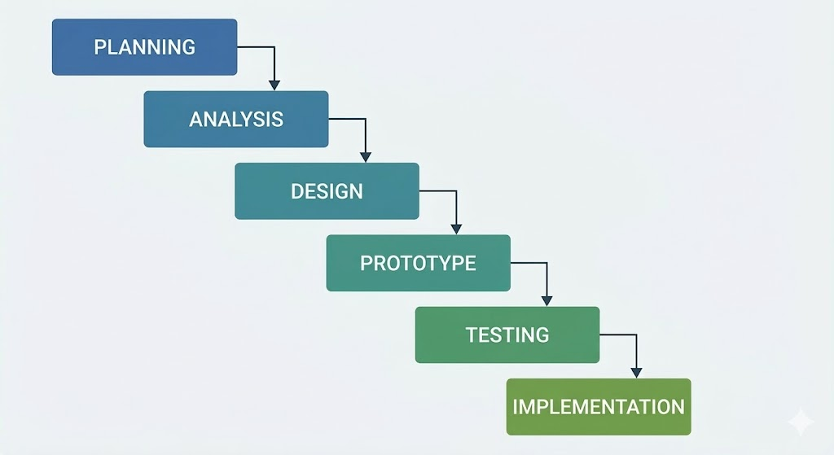
Figure 3.1. 1:Methodology Waterfall
Figure 3.1.1shows the waterfall model to ensure a structured and systematic development process. This linear approach guarantees that each phase is thoroughly completed before moving on to the next, thus ensuring the goal of "simplicity" is achieved.
Planning: The initial phase of the project includes defining the project scope and identifying the target audience, primarily job seekers. During this phase, will develop a timeline to ensure the project completes all steps within the stipulated timeframe, from identifying user pain points to delivering a fully functional Figma prototype.

Analysis: The analysis phase focuses on understanding the "pain points" of existing job search applications. This includes gathering demand by observing the difficulties users currently encounter when using complex platforms like LinkedIn or JobStreet. The goal of this phase is to identify which features (such as direct contact phone numbers and simple job listings) are needed.

Design: According to the analysis, the design phase included creating blueprints for the application interface. This involved drawing wireframes and defining user flows to ensure job seekers could find contact numbers with as few clicks as possible. The focus was on a clean, unobtrusive layout that was intuitive and easy to use for native users.
Prototype: Using Figma, static design drafts were transformed into interactive prototypes. A clickable model was created to simulate realistic user experience. The prototype focuses on core functionality: viewing a filtered list of jobs and accessing direct contact information for employers.

Testing: Once the prototype is complete, it will be tested to evaluate its usability. We will invite local users (such as students or job seekers) to try out the Figma prototype and see if they can find jobs and phone numbers faster than using traditional applications. Their feedback is crucial and helps confirm whether the design truly reduces user frustration and cognitive load.

Implement: The final phase involves finalizing the design based on test results and preparing for the final demonstration of the project. Although this project focuses on a high-fidelity prototype rather than a complete backend deployment, the implementation phase ensures the consistency of the design system, complete documentation, and its usability as a practical solution for the local community.

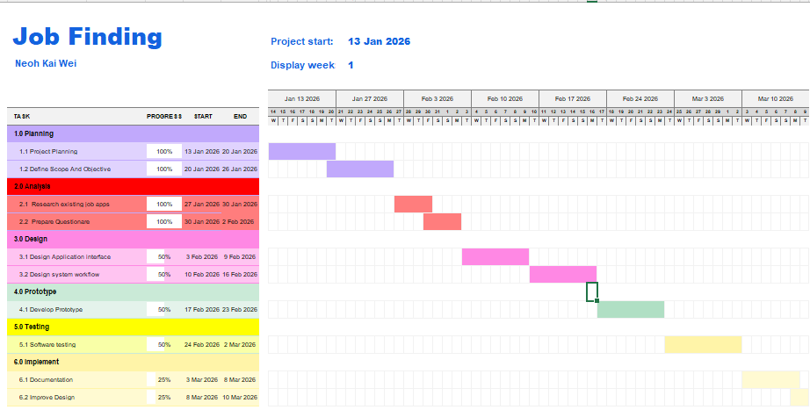
Figure 3.1. 2:Gannt Chart
Figure 3.1.2 shows Gannt Chart illustrates the comprehensive project timeline for the "Job Finding" application, structured according to the Waterfall methodology. The project spans from 13 January 2026 to 10 March 2026, divided into six distinct sequential phases.

Main Requirements
The system's core functional requirement is to display a static list of jobs that users can browse easily. Each job entry, when clicked, will lead to a specific Contact Page that clearly shows the employer's phone number and the shop's address. Non-functional requirements focus on simplicity and speed, ensuring that the interface is clean, uses large readable fonts, and allows a user to find contact information in as few clicks as possible.

Hardware and Software Requirements
To develop and demonstrate this prototype, specific hardware and software requirements were identified. A laptop was used throughout the design process to create and refine the interface layouts, while a mobile smartphone was employed to test the interactive Figma prototype in a real-world handheld environment, allowing for accurate simulation of how actual users would interact with the application on their devices. For software, Figma served as the primary tool, enabling the complete design of the interface elements and the creation of a fully clickable prototype that demonstrated the intended user flow from login through job searching, application tracking, messaging, and profile management. This combination of tools ensured the prototype could be efficiently developed and realistically evaluated without unnecessary complexity.

Testing Strategies
The project will employ usability testing as the primary method to measure the system’s efficiency. A group of three to five participants, specifically university students who are actively looking for part-time work, will be recruited as testers. These participants will be sourced from the SEGi University & Colleges campus in Subang Jaya area. Each tester will be given a specific task to complete on the prototype. This approach ensures the prototype is assessed under real-user conditions, providing clear evidence of its simplicity and speed.

Conclusion
In summary, the waterfall model provides a clear roadmap for transforming the complex recruiting experience into a streamlined and efficient digital tool. By following this step-by-step process, each stage serves as a quality control measure: the analysis stage ensures we are addressing the right problems; the prototyping stage turns a minimalist vision into reality; and the testing stage verifies whether we have truly alleviated the "annoyances" of modern job hunting.

CHAPTER 4

SYSTEM DESIGN

Introduction
The system design phase is a core part of the software development lifecycle, its main task being to transform the initial requirements analysis into a concrete technical architecture and logical blueprint. Previous chapters have clearly pointed out that current job search platforms in Malaysia generally suffer from overly cumbersome processes, high registration thresholds, and information overload.
Therefore, this chapter's design work will focus on the core goal of "simplification," using a structured design approach to build an efficient, transparent mobile job search prototype with good user experience. This chapter will detail the system's technical architecture design from three dimensions: functional architecture, business flow, and data relationships, ensuring that the system effectively reduces the user's cognitive burden while implementing core functions.

Use Case Diagram
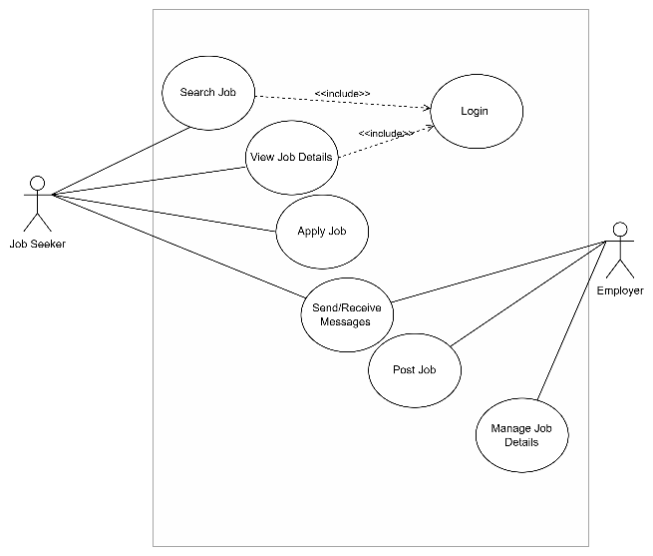
Figure 4.2. 1:Use Case Diagram
Figure 4.2.1 shows the Use Case Diagram illustrates the functional requirements of the job matching platform. The system facilitates interaction between two primary actors: the Job Seeker and the Employer.
A key design feature of this system is the mandatory authentication; both "Search Job" and "View Job Details" use cases have an <<include>> relationship with the "Login" use case, ensuring that only registered users can access core search functionalities. The "Send/Receive Messages" use case serves as a collaborative interface where both actors can interact. On the administrative side, the Employer is solely responsible for the lifecycle of a job post through "Post Job" and "Manage Job Details".

System Flow Chart
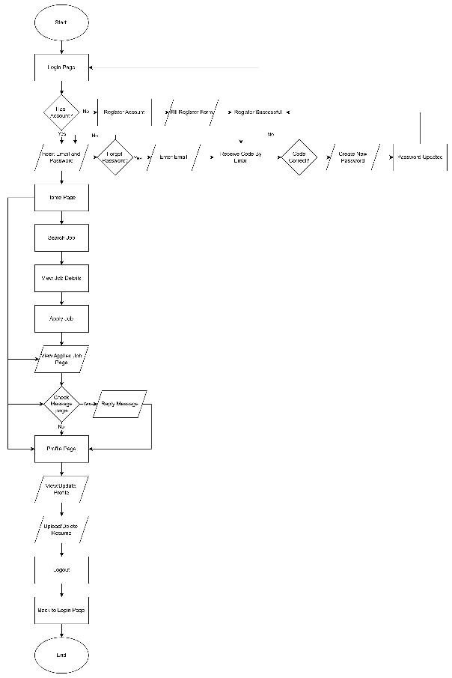
Figure 4.3. 1:Flow Chart

Figure 4.3.2 shows the flow logic demonstrates a user-centric design that prioritizes accessibility and functionality. By integrating a seamless password recovery system and a direct path from job discovery to application, the platform minimizes friction. The inclusion of a dedicated "Message Box" and "Resume Upload" feature ensures that the application remains a comprehensive tool for career management rather than a simple job board.

ERD Diagram
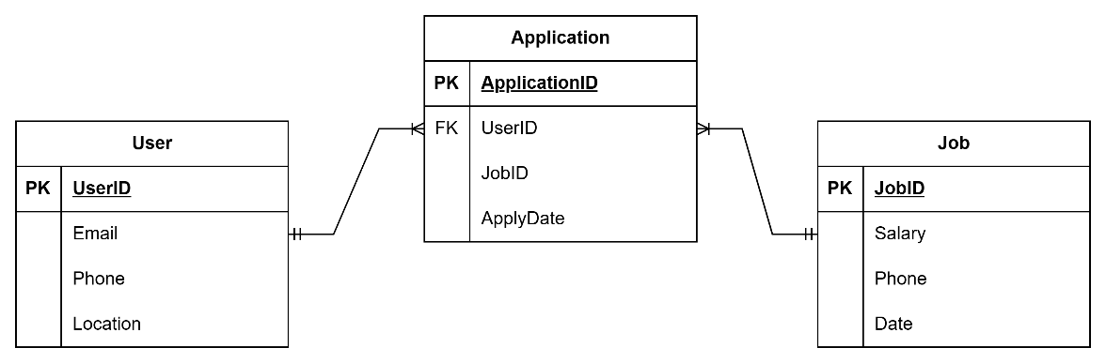
Figure 4.4. 1:ERD Diagram
Figure 4.4.1 shows Database Design Narrative: The Entity Relationship Diagram (ERD) establishes a robust foundation for the platform's data integrity. By utilizing an associative entity, "Application", the system efficiently resolves the complex many-to-many relationship between Users and Jobs.
The design ensures data normalization by isolating user-specific attributes (Email, Location) from job-specific attributes (Salary, Date). The use of UserID and JobID as foreign keys within the Application table allows for seamless data retrieval, enabling features such as application history tracking and employer-side applicant management. This structure is scalable and supports future expansions, such as adding application statuses or interview scheduling timestamps.

Conclusion
In conclusion, this study addresses the key pain points of existing mobile job applications in Malaysia lengthy registration processes, lack of application tracking and direct employer contact, and inadequate search/filter functionalities by proposing a streamlined mobile job-finding platform. Through detailed user analysis, Use Case Diagram, Flow Chart, and ERD modelling, the proposed system achieves the objectives of enabling instant job browsing without registration, providing basic application tracking with direct contact access, and enhancing search capabilities for quick, local, and casual job opportunities.

CHAPTER 5

PROTOTYPE

Introduction
This chapter presents the prototype developed for the Job Finding Application. The prototype was designed using Figma to demonstrate the interface layout, navigation structure, and core functionalities of the proposed mobile job search system.
The main purpose of this prototype is to visualize how the simplified job search platform operates and how users interact with the system. Unlike traditional job platforms that require lengthy registration processes and complex navigation, this prototype focuses on providing a minimalist and user-friendly interface that allows users to quickly access job listings and employer contact information.
The prototype includes several key screens such as login, registration, job listing, job details, job application, messaging, FAQ, and user profile. Each screen is connected through interactive navigation to simulate a mobile application experience. Through this prototype, users can easily browse available jobs, view job descriptions, and directly contact employers.
Overall, the prototype demonstrates how the proposed system reduces unnecessary complexity while improving accessibility and usability for students and part-time job seekers in Malaysia.

Prototype
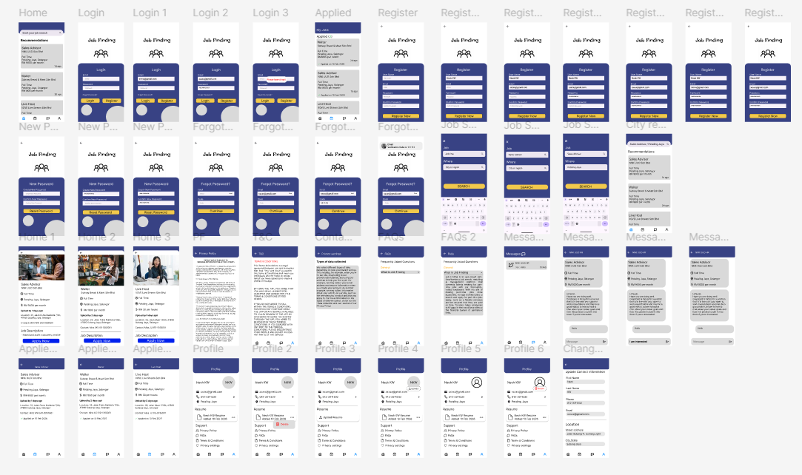
Figure 5.2. 1: Prototype

Figure 5.2.1 shows a high-fidelity prototype interface of a job search application developed using Figma. The prototype consists of multiple interconnected screens, simulating the functionality of a real mobile job search platform.
The interface includes key modules such as a login and registration page, job search and job listing page, job details page, application form, messaging interface, Frequently Asked Questions (FAQ) section, and user profile management. The design employs a minimalist layout with clear navigation, allowing users to easily switch between different parts of the application.
The job listing page allows users to quickly browse available jobs, while the job details page provides essential information such as job descriptions, location, and employer contact information. The messaging function supports communication between job seekers and employers, improving interaction and follow-up opportunities
In addition, auxiliary pages such as terms and conditions, contact information, and the FAQ provide necessary guidance and support for users when using the application.
In summary, this prototype demonstrates how a simplified mobile interface can improve job search experience by reducing information overload and helping users find job opportunities more efficiently.

Conclusion
This project aimed to design and developed a user-friendly mobile job search application prototype to help Malaysian students and part-time job seekers access job opportunities more efficiently. Research revealed numerous problems with existing job search platforms, including lengthy registration processes, a lack of direct employer contact information, and complex navigation systems.
To address these issues, this project adopted a waterfall development methodology, providing a structured framework for planning, analysis, design, prototyping, and testing. Through requirements analysis and system design, we proposed a streamlined mobile interface that minimizes unnecessary complexity while retaining essential job search functionality.
And successfully developed a prototype using Figma, creating a high-fidelity interactive model that simulates realistic user experience. The design emphasizes simplicity, enabling users to quickly browse job listings, view job details, and obtain employer contact information in minimal steps. This approach significantly reduces user frustration and improves job search efficiency.

CHAPTER 6

TESTING AND EVALUATION

Introduction
This chapter describes the testing and evaluation process of the proposed job search application prototype system. The aim is to verify the system's functionality and evaluate its usability from a user perspective.
First, we used a series of test cases to ensure that the system's core functions (such as registration, login, job search, and viewing job details) functioned as required. Each test case included preconditions, test steps, and expected results to determine if the system operated as intended.
Second, we conducted a usability evaluation through a questionnaire survey. We invited a group of users to interact with the Figma prototype and provide feedback on the system's usability, navigation, and overall user experience.
Finally, we analyzed the survey results and presented them using charts to identify the system's strengths and potential areas for improvement. These findings help determine whether the developed prototype system successfully achieved its goal of providing a simple and efficient job search platform.

Questionnaire
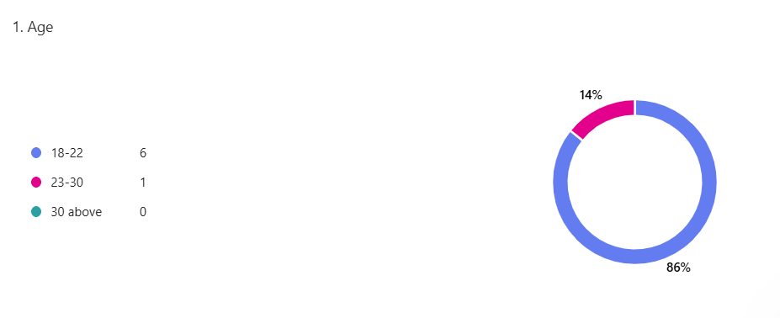
Figure 6.1. 1:Age
Figure6.1.1:Age shows this demographic question was included to collect essential background information and verify that the testers accurately represent the target user group university students and part-time job seekers in Malaysia, who are typically aged between 18 and 25 years old. Gathering age data ensures that the usability test results and feedback on the login process, registration page, home screen navigation, and overall prototype simplicity are relevant and reliable.

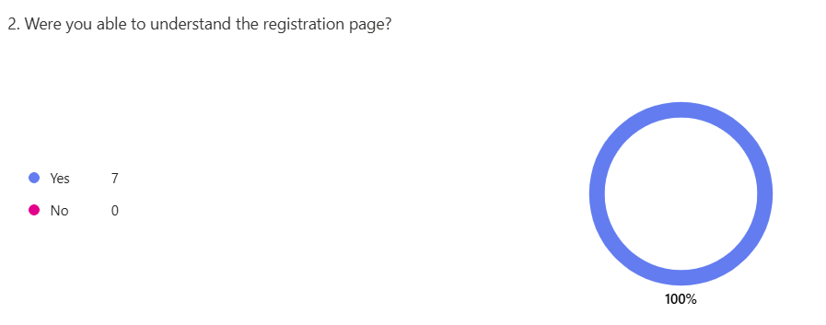
Figure 6.1. 2
Figure 6.1.2 shows this question was included right after the usability task to specifically verify that the registration flow felt clear and straightforward, confirming that the prototype successfully removed the long and confusing sign-up barriers commonly found in other job apps. The results showed that the registration page was easy to understand because it uses a single, clean screen with only six clearly labelled fields (Username, Email, Password, Confirm Password, Location, and Phone Number) arranged in logical order. There are no extra steps, no confusing verification layers, and no unnecessary information required.

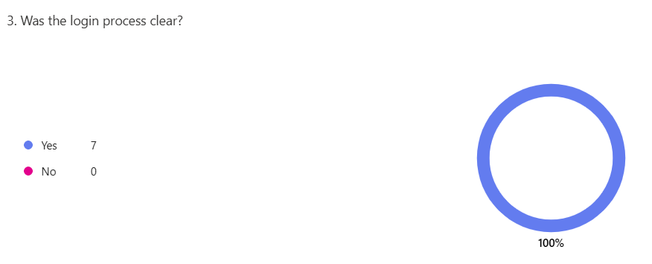
Figure 6.1. 3:Process Clear
Figure 6.1.3:Process Clear shows this question was deliberately included immediately after each tester completed the usability task to confirm whether the prototype’s authentication flow felt intuitive and easy to follow, thereby validating one of the core goals of the project removing unnecessary complexity from the very first user interaction.

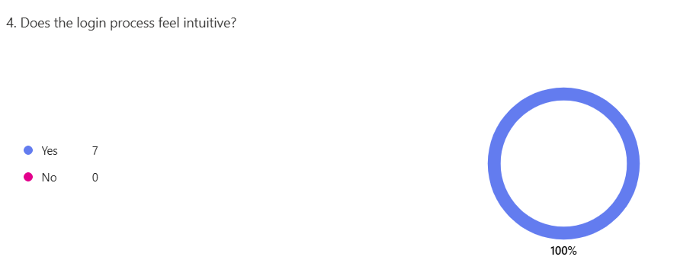
Figure 6.1. 4
Figure 6.1.4 shows this question was included immediately after the usability task to evaluate whether the authentication flow felt natural and effortless rather than forced or confusing, directly validating the prototype’s core “back to basics” design principle. The results showed that the login process felt highly intuitive because the screen presents only two simple input fields (Email and Password) with large, clearly labelled buttons and no unnecessary steps or hidden options.
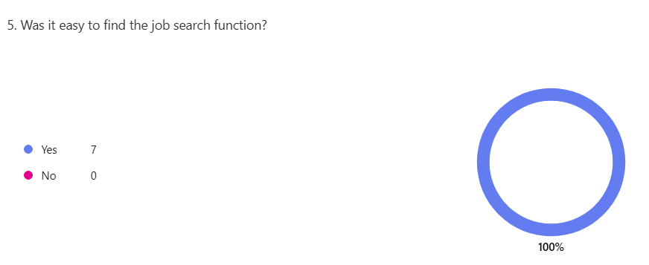
Figure 6.1. 5
Figure 6.1.5 shows this question was included right after the usability task to verify that users could immediately locate the core job-search feature upon entering the app, directly testing the prototype’s minimalist design goal of making job discovery fast and obvious without any hidden menus or confusing navigation. The results confirmed that the job search functions were very easy to find because the Home Page prominently displays both recommended jobs and a clear search bar at the top.

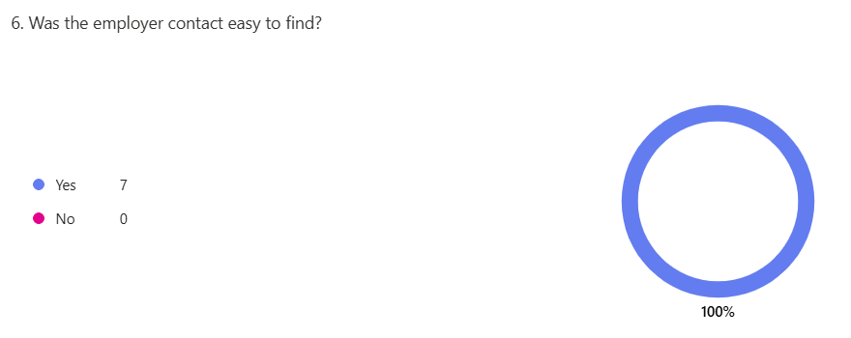
Figure 6.1. 6
Figure 6.1.6 shows this question is used to evaluate whether users can easily locate the employer's contact information in the prototype. Since the application aims to simplify the job application process, users should be able to quickly find the employer’s contact details after viewing a job listing. The feedback helps determine whether the interface layout is clear and whether the contact information is placed in a visible and accessible location

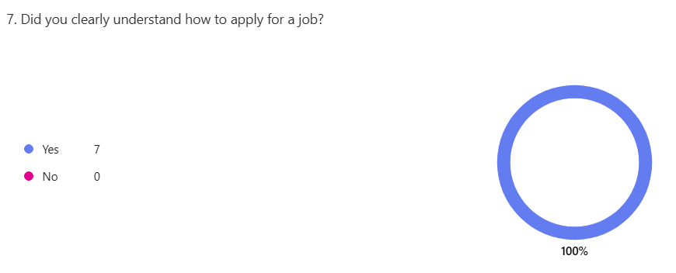
Figure 6.1. 7
Figure 6.1.7shows this question is used to evaluate whether users can clearly understand the job application process in the prototype. After testing the system, users are asked this question to determine if the steps required to apply for a job are easy to follow. If users understand the process clearly, it shows that the application flow and interface design are simple and effective. If users experience confusion, improvements may be needed to make the job application process more intuitive.
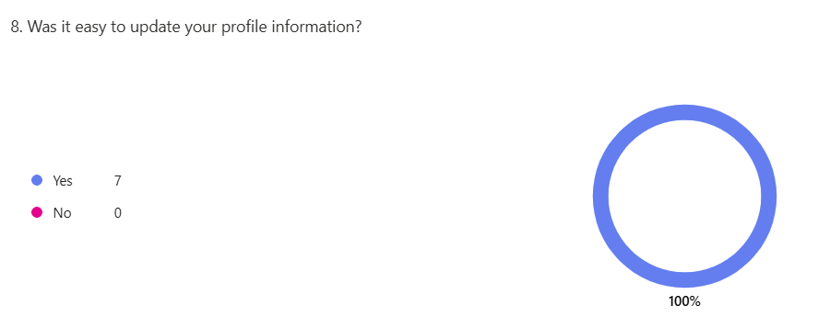
Figure 6.1. 8
Figure 6.1.8 shows this question is used to evaluate whether users can easily edit or update their profile information in the prototype. After testing the profile feature, users are asked this question to determine if the process of changing personal details is simple and understandable. If users find it easy, it shows that the profile interface and navigation are clear. If users have trouble, improvements may be needed to make the profile management process more user-friendly.

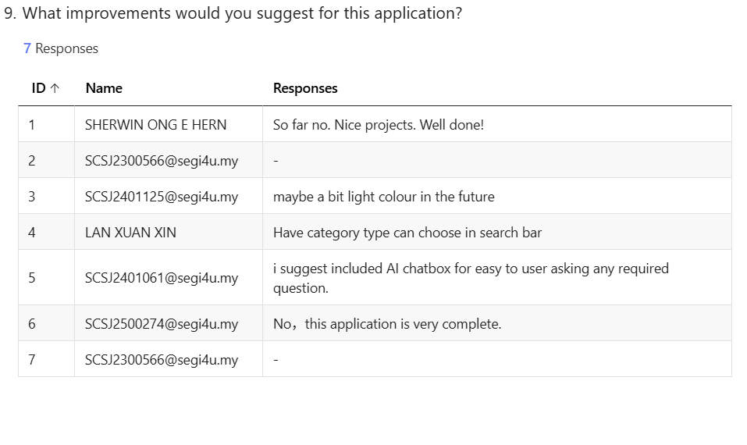
Figure 6.1. 9
Figure 6.1.9 shows this question is used to collect user feedback and suggestions after they complete the testing of the prototype. It allows users to provide their opinions on how the application can be improved, such as enhancing features, improving the interface design, or simplifying certain processes. The feedback helps identify areas that need improvement and provides useful insights for future development of the application.

Conclusion
In summary, the testing and evaluation process confirmed that the proposed job search application prototype functions as intended. Test cases validated the system's core functionalities, including registration, login, job browsing, and job detail viewing, all of which functioned correctly.
Usability evaluation results also indicated that most participants found the system easy to use and understand. The clean interface and clear navigation helped users quickly find job information and employer contact details. This aligns with the project's main goal of creating a simple and efficient job search platform for students and part-time job seekers.
While the prototype demonstrated good usability, some improvements can still be made in future development, such as adding more job filtering options and implementing real-time job updates. Overall, the test results demonstrate that the proposed system successfully improves the job search experience by reducing complexity and enhancing usability.

CHAPTER 7

CONCLUSION

Introduction
This chapter concludes the study by summarizing the key findings of the project in relation to the research objectives. It also highlights the contributions of the proposed system, discusses the limitations encountered during the development process, and provides recommendations for future improvements. The aim of this chapter is to provide an overall reflection on the development of the Job Finding Application prototype and its potential value for students and part-time job seekers in Malaysia.

Contribution of the Study
This project aims to contribute to the field of mobile job search system design by proposing a simplified platform that emphasizes ease of use and efficiency. Unlike traditional recruitment platforms that emphasize complex features and professional networks, this system focuses on providing a quick way to access local job opportunities.
Prototype validation shows that a clean and intuitive interface reduces cognitive load, simplifies the job search process, and thus enhances the user experience. Furthermore, this project emphasizes the importance of directly providing employer contact information, which helps speed up communication and increase the success rate of job applications.
The findings of this research can also provide valuable insights for designers and developers working to improve digital recruitment platforms, particularly for students, part-time job seekers, and small businesses in Malaysia.

Limitations of the Study
Although the project successfully developed a functional prototype, several limitations were identified during the research process. First, the system developed in this project was only a prototype created using Figma, meaning it did not include a fully implemented backend system or real-time database functionality.
Second, the usability testing involved a small number of participants, primarily students from SEGi University. Therefore, the test results may not fully represent the experience of a larger, more diverse user group.
Furthermore, due to time and resource constraints, the prototype focused primarily on interface design and basic interactions, rather than advanced features such as automated job matching, integrated messaging systems, or real-time job updates.

Recommendations for Future Work
Future iterations should implement a push notification system to instantly notify users of new job openings, ensuring that applicants can react promptly to opportunities and significantly increasing engagement and the platform's overall utility. Furthermore, development could involve the integration of GPS technology for geospatial optimization to enable precise nearby filtering. By leveraging real-time location data, the system can provide highly localized job suggestions, making the search process more efficient for users prioritizing proximity.

Conclusion
In conclusion, this project successfully designed and developed a minimalist mobile job search application prototype aimed at improving the job search experience for Malaysian students and part-time workers. The system emphasizes simplicity and ease of use, and supports direct communication with employers, demonstrating how simplifying unnecessary complexity can improve usability and efficiency. Although currently only a prototype, it lays a solid foundation for future development and highlights the potential advantages of simplifying mobile recruitment platforms.

REFERENCES

Hazarika, B., Shrivastava, U., Hiele, T. M., & Pham, C. (2025). The impact of technology frustration and consumer passion on consumer evaluation shift in case of mobile apps. Acta Psychologica, 256, 105006. https://doi.org/10.1016/j.actpsy.2025.105006
‌
Fitria Fitria, Yahya, M., Ali, M. I., Purnamawati Purnamawati, & Mappalotteng, A. M. (2024). The Impact of System Quality and User Satisfaction: The Mediating Role of Ease of Use and Usefulness in E-Learning Systems. International Journal of Environment Engineering and Education, 6(2), 119–131. https://doi.org/10.55151/ijeedu.v6i2.134

Roslan, A. M. A., Pahme, N. F. M., & Rahim, I. M. A. R. A. (2025). Evaluating on Mismatches and Inaccurate Recommendations of Job Matching Platform: The Effectiveness of Mobile Job Matching Platform in Malaysia. International Journal of Research and Innovation in Social Science, 9(23), 240–251. https://doi.org/10.47772/ijriss.2025.923mic3st250021

Fam, S.-F., Soo, J. H., & Wahjono, S. I. (2017). Online Job Search Among Millennial Students in Malaysia. Jurnal Dinamika Manajemen, 8(1). https://doi.org/10.15294/jdm.v8i1.10406

‌ GeeksforGeeks. (2018, March 18). Waterfall Model Software Engineering. GeeksforGeeks. https://www.geeksforgeeks.org/software-engineering/waterfall-model/

Oh, J., Kim, J., & Lee, Y. (2014). The impact of system complexity on user frustration in mobile applications. International Journal of Mobile Communications, 12(3), 211-228
Roslan, A. M. A., Pahme, N. F. M., & Rahim, I. M. A. R. A. (2025). Evaluating on Mismatches and Inaccurate Recommendations of Job Matching Platform: The Effectiveness of Mobile Job Matching Platform in Malaysia. International Journal of Research and Innovation in Social Science, 9(23), 240–251. https://doi.org/10.47772/ijriss.2025.923mic3st250021

Rasool, T., Warraich, N. F., & Sajid, M. (2022). Examining the Impact of Technology Overload at the Workplace: A Systematic Review. SAGE Open, 12(3). https://doi.org/10.1177/21582440221114320

Arnold, M., Goldschmitt, M., & Rigotti, T. (2023). Dealing with information overload: A comprehensive review. Dealing with Information Overload: A Comprehensive Review, 14(1122200). https://doi.org/10.3389/fpsyg.2023.1122200

‌ Fang, Y. X., Gill, S. S., Kunasekaran, P., Rosnon, M. R., Talib, A. T., & Abd Aziz, A. (2022). Digital Divide: An Inquiry on the Native Communities of Sabah. Societies, 12(6), 148. https://doi.org/10.3390/soc12060148

Abraham, M. (2020). Strategic recruitment and selection in Malaysian small and medium enterprises: unravelling the evidence of fit - Nottingham ePrints. Nottingham.ac.uk. https://eprints.nottingham.ac.uk/59806/1/Mathew%20PhD%20Final%2020%20Jan%2020.pdf

‌Osborne, H., & Vandenberg, P. (n.d.). ASIAN DEVELOPMENT BANK JOB MATCHING FOR YOUTH IN ASIA AND THE PACIFIC A TRANSITIONS APPROACH FOR POSITIVE LABOR MARKET PATHWAYS. https://www.adb.org/sites/default/files/publication/923096/job-matching-youth-asia-pacific.pdf

Tunku, U., & Rahman, A. (2025). JOB SEARCH SELF-EFFICACY, WORKPLACE ANXIETY AND CAREER EXPLORATION AMONG FINAL YEAR STUDENTS IN MALAYSIA. http://eprints.utar.edu.my/6180/1/2205649_Dissertation.pdf

Venkatesh, H. (2018, June 24). Search made easy with the JobStreet app — a UX case study. Medium; UX Collective. https://uxdesign.cc/jobstreet-com-app-revamp-91523cd7eccb

Muzayyin Isnainy. (2022, February 14). UI/UX Case Study: Redesigning JobStreet Mobile App for Better Job Applying Experience. Medium. https://medium.com/@zayyinisnainy/ui-ux-case-study-redesigning-jobstreet-mobile-app-for-better-job-applying-experience-9361df0197e5

Emir Abiyyu. (2023, January 21). Improving Jobs Filter Experience in JobStreet App — a UI/UX Case Study. Medium. https://medium.com/@emirabiyyu/improving-jobs-filter-experience-in-jobstreet-app-7464aaacda29

APPENDICES
